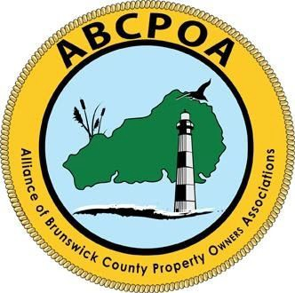

Alliance of Brunswick County Property Owners Associations

PO Box 1686, Shallotte, NC 28459
www.abcpoa.net

ABCPOA APPLICATION FOR MEMBERSHIP

Name
POA/HOA
Street
City,
State
Zip Re: ABCPOA APPLICATION FOR MEMBERSHIP

Dear Sir/Madam Thank you for your interest in the Alliance of Brunswick County POA’s (ABCPOA) and your intent to join as a full member. You will find a copy of the Bylaws of the ABCPOA on our website abcpoa.net.

Please provide the following:

A) Primary Contact Name, phone contact & email address.
B) A letter (email acceptable) of intent by the Associations President addressed to: - Secretary or Treasurer of ABCPOA, (email addresses to be provided on request)
C) Your Associations demographics:
1) Number of Single-Family Homes
2) Number of Condo units
3) Number of Vacant, but sold and dues paying lots
4) Total membership of Association (1+2+3)
5) Number of Developer lots, not sold 6) Is Association Developer controlled?
D) Copy of Certificate of Incorporation issued by NC Secretary of State.
Note: If not readily available got to the website of the Secretary of State and enter full name of the Association and year of incorporation as a non-profit organization.

The current dues are $125.00 / year.

Please feel free to email me presidentabcpoa@gmail.com

We are looking forward to hearing from your Association. Thank you.

