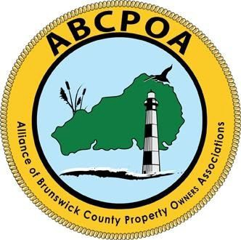

Alliance of Brunswick County Property Owners Associations

PO Box 1686, Shallotte, NC 28459
www.abcpoa.net

August 2024

To: Candidates for County Commissioner
DISTRICT 03
Patricia L Sykes, (incumbent) (R)
Robert (Bob) Fulton (D
DISTRICT 04
Mike Forte, (incumbent) (R)
Tom Simmons (D)
DISTRICT 05
Frank Williams (incumbent) (R)
Jonathan Damico (D)

From:
Gene Vasile, President
Alliance of Brunswick County Property Owners Associations (ABCPOA)

As the 2024 General Election for the positions of County Commissioners approaches, in lieu of an independent “in person” candidate forum, the ABCPOA is conducting a brief survey of each candidate’s positions on issues of importance identified by its membership.

The attached survey consists of issue-oriented questions. Candidates’ responses will be placed on the ABCPOA website, abcpoa.net and will be distributed internally through our thirty-one Member Associations.

The ABCPOA is an issue driven, non-partisan, organization and shall not endorse any candidate.

To complete the survey, simply open the attachment, indicate your name and district and enter your responses. On completion, please save your document and forward it to me by September 20, 2024 at presidentabcpoa@gmail.com.

I look forward to hearing from you. Please contact me directly if you have any questions.

Best regards
Gene Vasile
presidentabcpoa@gmail.com
910-232-2093

